

Cimarron High School News
October 2018 Edition

Picture Day—CHS Picture Day is Tuesday, October 9.

College and Career—from the Guidance Counselor
*The Preliminary Scholastic Aptitude Test/New Mexico Scholarship Qualifying Test (PSAT/NMSQT) will be administered on October 10th for all interested Juniors and Sophomores. It is considered a practice test for sophomores and used to determine eligibility for scholarships for juniors. Interested students must register with Mr. Salas to take the exam.
*A Financial Aid Workshop for students and parents, particularly seniors, has been tentatively scheduled for Thursday, October 11th at 6:00 at Cimarron High School. Additional information regarding this workshop as well as a Free Application for Federal Student Aid (FAFSA) Completion Workshop will be provided as it becomes available.
*Red Ribbon Week will occur during the week of October 23rd at Cimarron Elementary, Middle and High Schools and will include presentations and activities promoting alcohol and drug free lifestyles.

There will be a DVR meeting on Oct. 9th at 1:30 (This is by invite only; if you didn't receive an invite, it is not applicable to you or your student).

From the Nurses office:
**The Consent forms and Flu packets arrived and were sent out to all students on Sept 19th to all those who returned their Flu Survey form. Parents must fill out all insurance information, answer all questions and sign consent form in order for you student to receive the Flu vaccine when it arrives. If you did not receive a packet, have your student stop by the Nurse's office and ask for a Flu packet or call my office and one will be sent home with your student.. PLEASE RETURN THE CONSENT FORM ASAP so that when the Flu vaccine arrives we are ready. If you have any questions or need a form, please feel free to call my office. 376-2512 extension 204.

Phones
All school phones at CEMS and CHS are up and running! Yay! Extensions have remained the same, unless a teacher is in a new room. When you call in, you can listen to the list of extensions if you don't know it for the person you wish to reach. Principal Martinez also would like to share her school cell phone number with you. It is 575-404-6102. Please feel free to call or text with any questions or concerns, but please only call between 7:00am and 9:00pm. If it is during the school day, please call her using her school extensions (202 at CEMS and 302 at CHS). Thank you!

Band Notes
*The CHS band had a spectacular trip to the State Fair on September 11-12th. They made digital media presentations on their scavenger hunt around the fairgrounds to commemorate their morning. They were also well received at their performance for the Red River Community House on September 9th.
*On October 18, the CEMS middle school bands will hold their annual BANDORAMA Parent Night at 6 PM in the CHS band room. This mock rehearsal/performance will serve as parent-teacher conferences for Band families. Come see what happens in a daily band rehearsal and sit next to your child to actually listen to how they are participating at this point in the semester. BANDORAMA is for band members, grades 6-8.
*The CHS Band has been invited to provide music for the annual School Board Association meeting and dinner at the high school on Monday evening, October 15th. Details will be sent out via all-call and flyer.

Band at State Fair Discussing 9/11 at the Fair Band at Red River
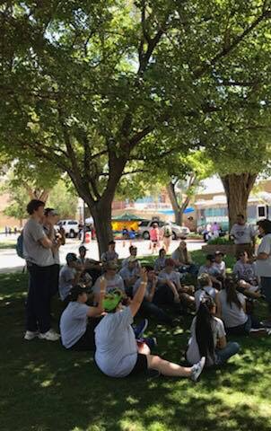
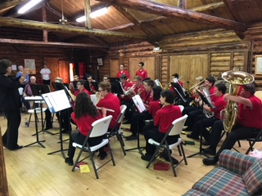
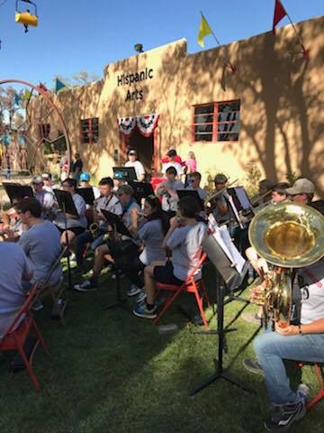
FFA Happenings
*FFA Big Red Barn--High school Students participated in working the big red barn this last Saturday. They got to teach people about different species of animals and also got to use their math skills when selling goods for our state FFA association.
*FFA Upcoming events: November 12,2018- District Creed Contest- in Logan at 4:00

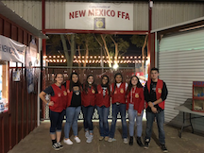

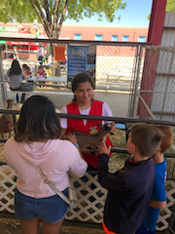

CHS newsletter continued on page 2
CHS Athletics
*Lady Rams took 3rd place in the 13th Annual Anna Archuleta Memorial Volleyball Tournament.
*The Dig Pink Game will be on October 13th vs. the Des Moines Demons--we need all the support we can get in the stands to please come out and support the Lady Rams!!
*If anybody is interested in playing in the Alumni Basketball Game in November--Please contact Alberta Martinez 575-643-5559. There will be opportunities for male and female players and depending on response --multiple games.

*13th Anna Archuleta Memorial VB Tournament is in the books!! Thank you, thank you, thank you to everybody who worked so hard this weekend to make it a success!! Coach Alberta Martinez, Rudy Coca, Lori Crowson, David Salas, Leslie Anderson, and the class of 2020, the RAMS basketball team members (Austin Vargas Matt Dean Morgan Sahd and Lee Kenneke) and Ashlyn Selph, Benji, Joe, and Teddy Salazar, Ashley Gonzales, Amber Archuleta,Beka Peterson, Leo Martinez, Lily Foley, Lawrence Coca, Rick Archuleta, Marlene Pittman, Jody Martinez, Nancy Holmgren, Peyton Adams, Daniel Vigil, Tiffany Airington, and the broadcast team, and anyone else we may have missed!! As you can see it takes teamwork to make the dream work and you all are the best!!!

CHS Volleyball for October

DATE | DAY | TIME | OPPONENT | LOCATION | DEPART* | TEAM

October 4 | Thursday | 4:00 | Monte Del Sol | Santa Fe | 1:00 | JV/Varsity
October 5 | Friday | 4:00 | Questa | Questa | 2:00 | EN/Cim/JV/V
October 6 | Saturday | 5:00 | Springer | Springer |  | Varsity
October 6 | Saturday | 9:00 | Clayton Tourney | Clayton | 6:30 am | EN / Cim MS
October 12 | Friday | 5:00 | Maxwell | Maxwell | 3:30 | EN Mid/Varsity
October 13 | Saturday | 4:00 | Des Moines | Cimarron |  | EN Mid/JV/Varsity
October 15 | Monday | 5:00 | Wagon Mound | Wagon Mound | 3:15 | Varsity
October 18 | Thursday | 4:30 | Roy/Mosquero | Mosquero |  | Varsity
October 25 | Thursday | 5:00 | Springer | Cimarron |  | EN/Varsity
October 26 | Friday | 5:00 | Wagon Mound | Cimarron |  | Varsity
October 27 | Saturday | 4:00 | Des Moines | Des Moines | 1:00 | Cim JH/JV/V

Cross Country
Cross Country for October

DATE | DAY | TIME | OPPONENT | LOCATION | DEPARTURE TIMES* | TEAMS
5 OCT | FRIDAY | 8:00 | JOHN GRIMLEY INVITE | SFIS | TBA (through Moreno Valley depart 4:00a.m | MS ,JV, V
13 OCT | SATURDAY | 8:00 | NORTHERN NM CHALLENGE | SANTA FE | TBA (through Moreno Valley depart 4:00 a.m | JV, V
20 OCT | SATURDAY | 8:00 | RIO RANCHO JAMBOREE | RIO RANCHO | TBA | JV,V

Check out the district website, www.cimarronschools.org, for athletic schedules, school and district information, the monthly newsletter, and much more!

Please see the calendar of events for October on the next page.

If you, or your organization, have any announcements, events, etc. to be included in our monthly newsletters, please email it to jmartinez@cimarronschools.org by the 3rd Friday of the month, in order for it to go out on the next month's newsletter.

